Cover page
- LinkPlease – Tech Intern Assignment
- Ayush Kumar
- Part A + B + C
- Deployment URL --- https://linkplease-assignment-ej7f.onrender.com

- Health Check
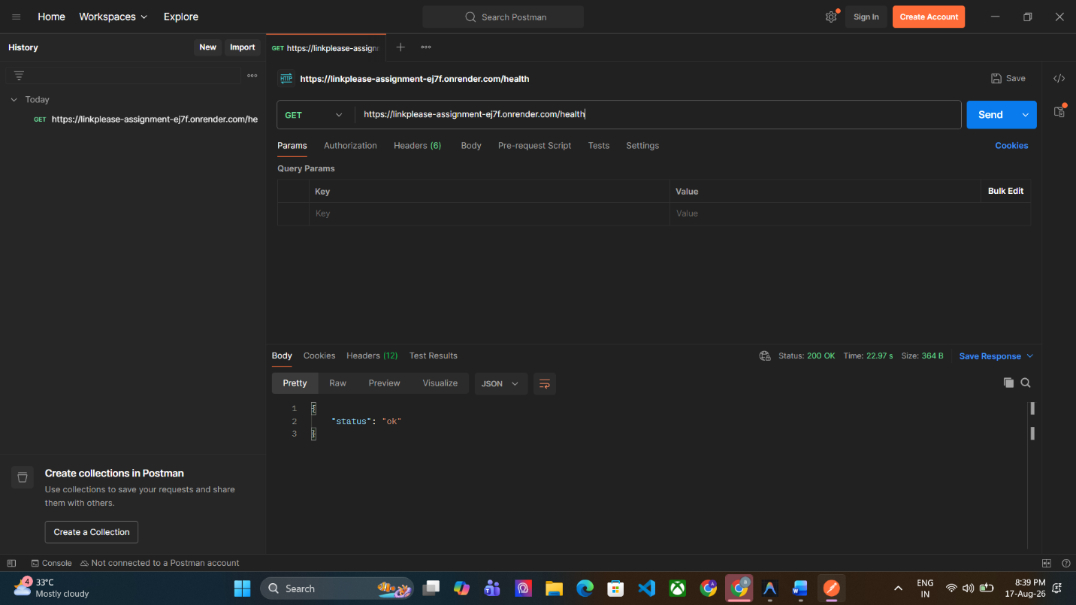

- Rule Creation
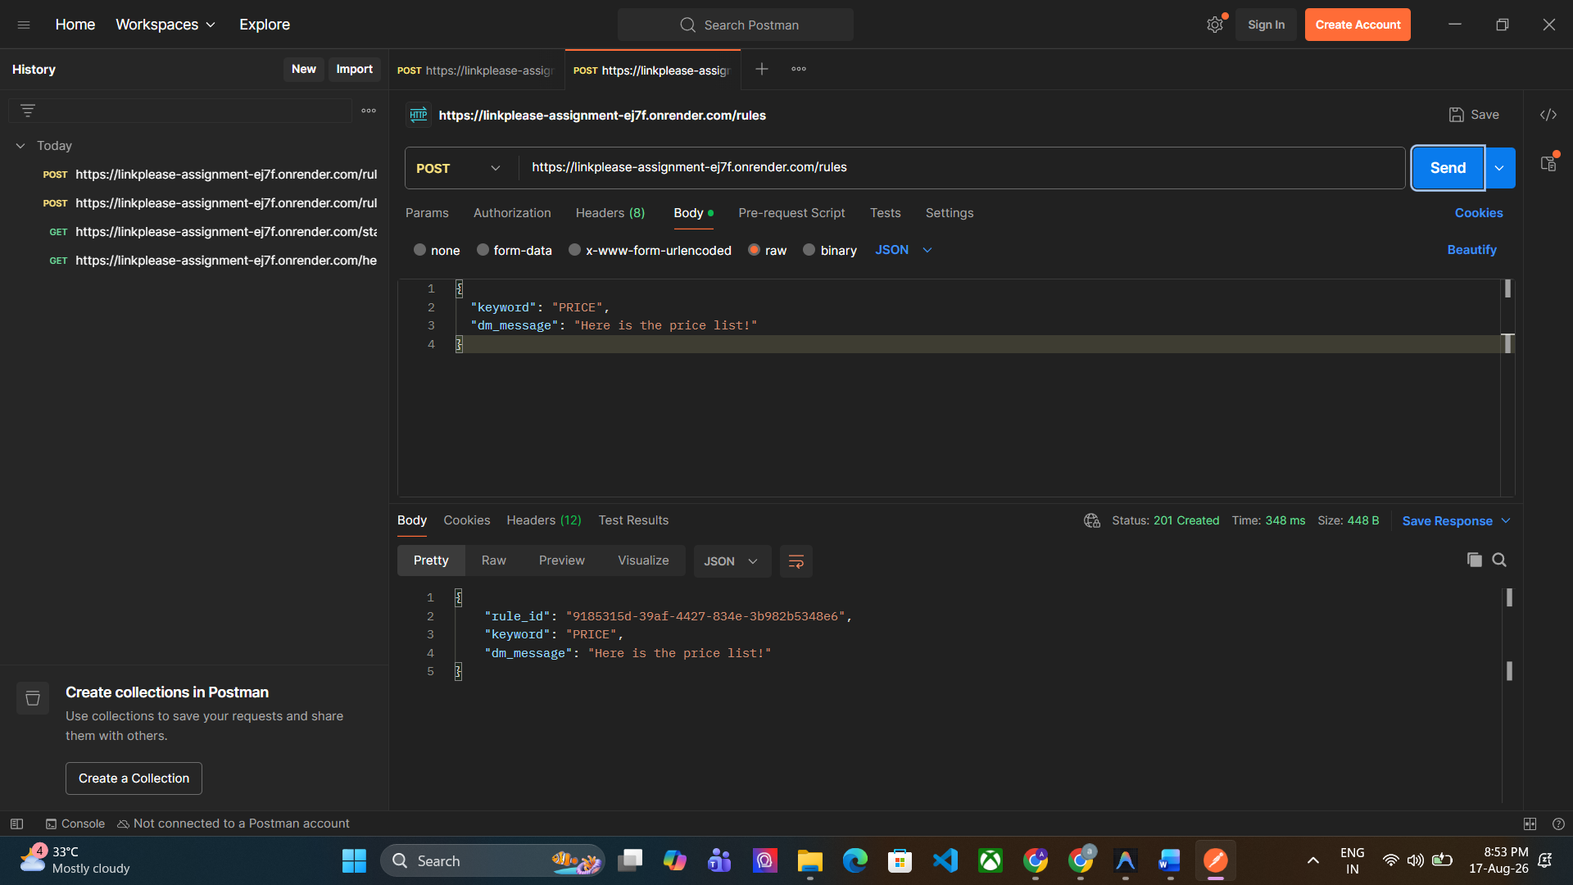

- Live Statistics
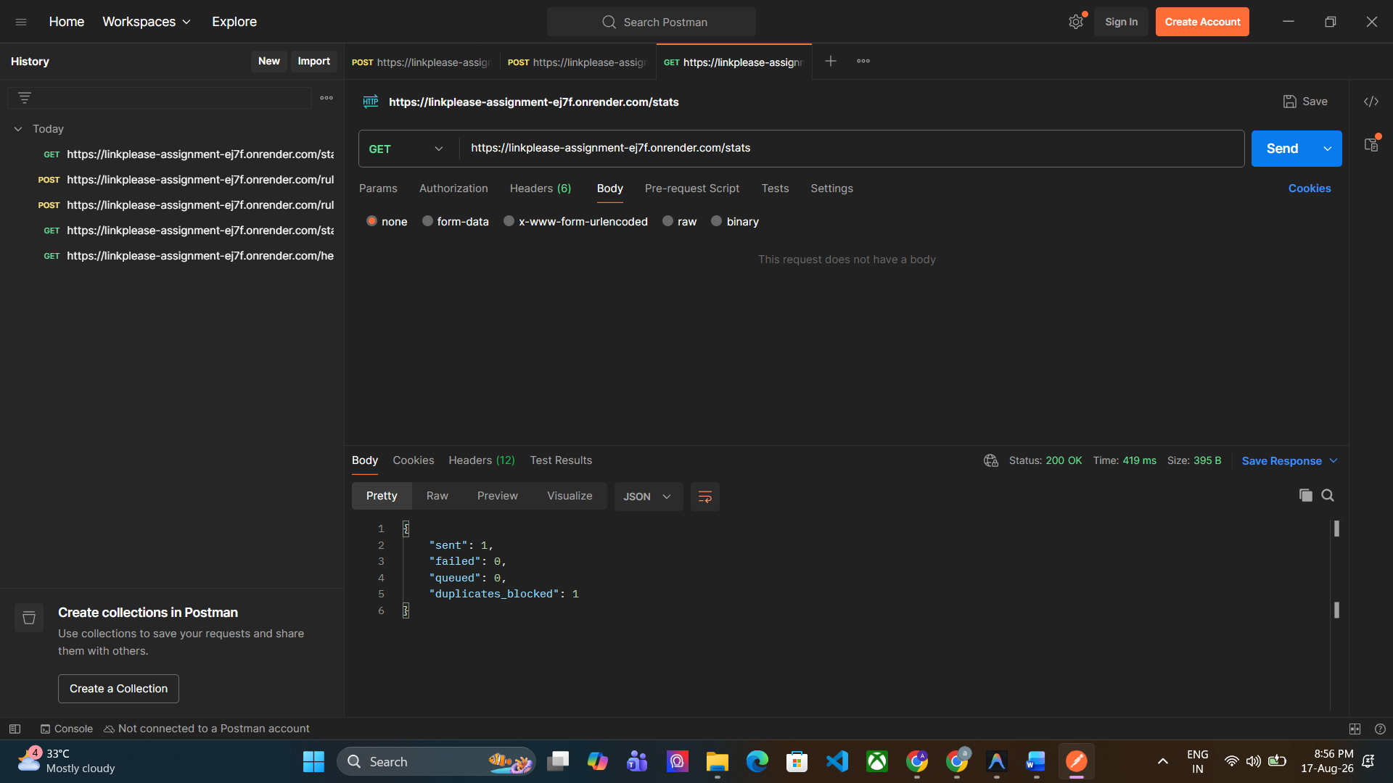
- Swagger API Documentation
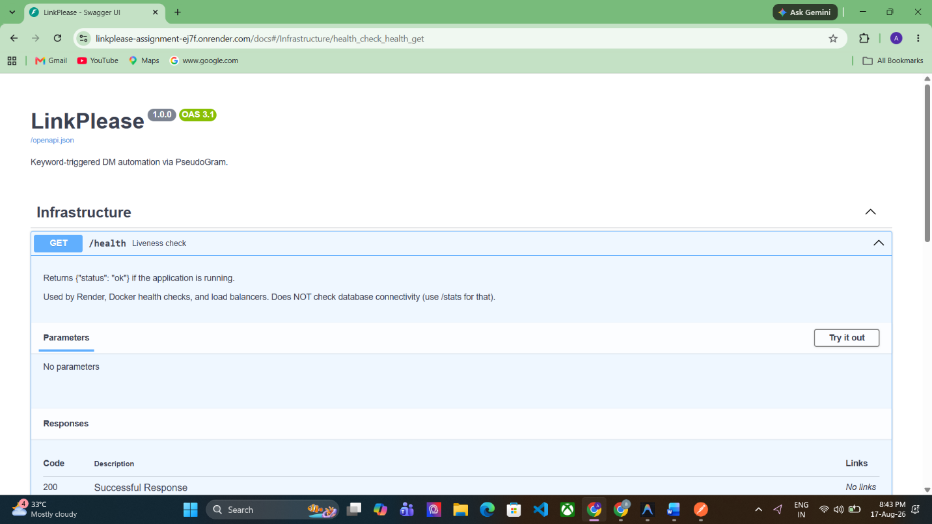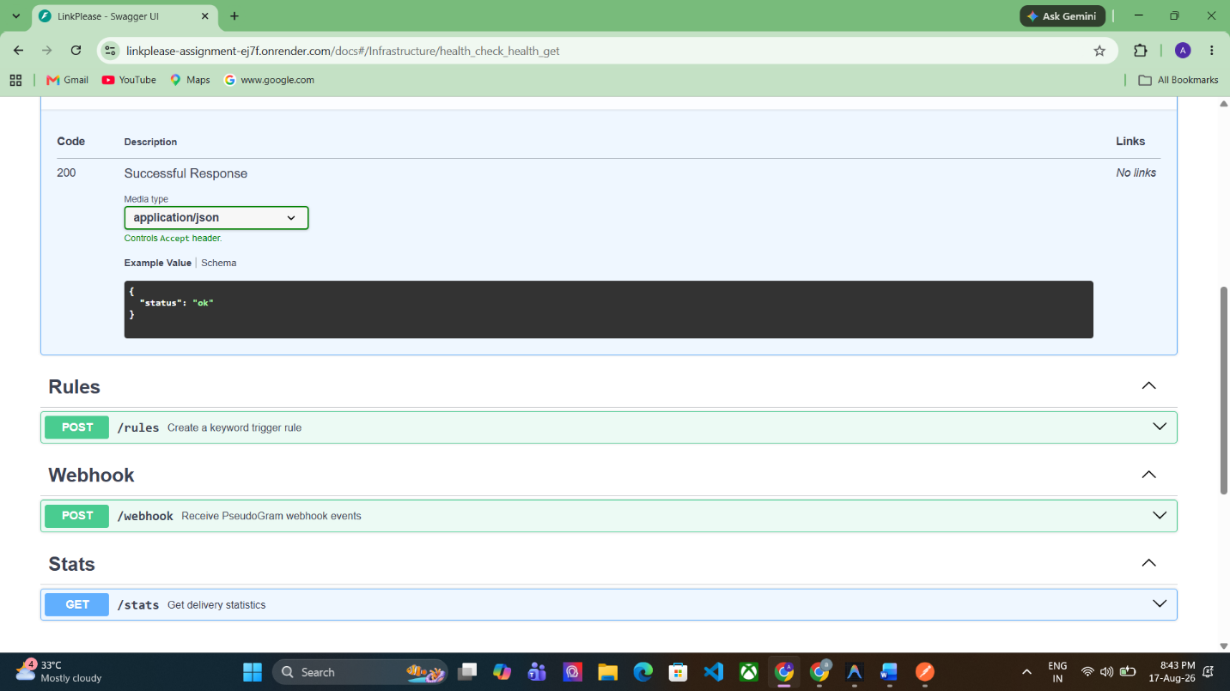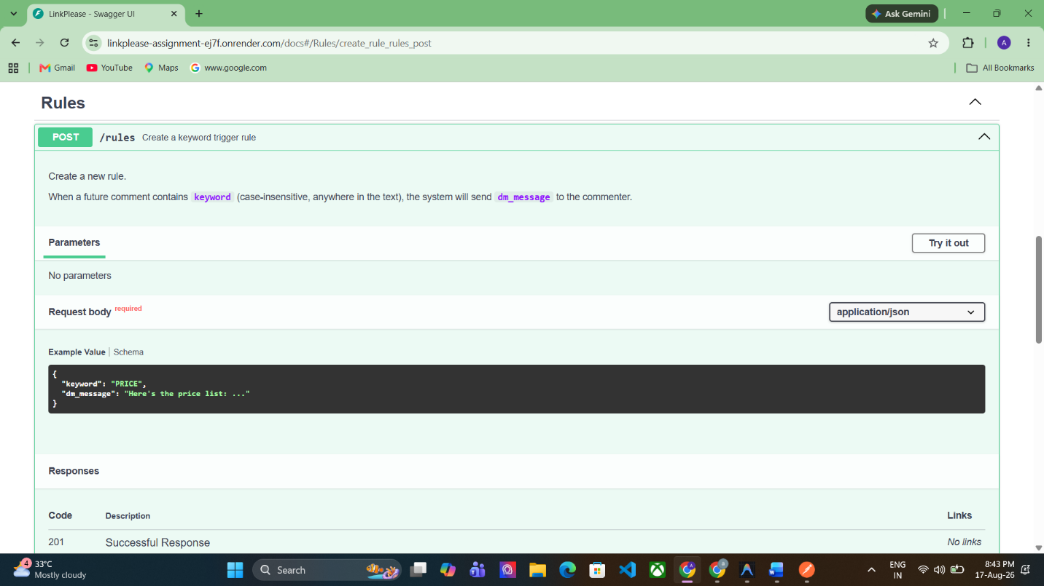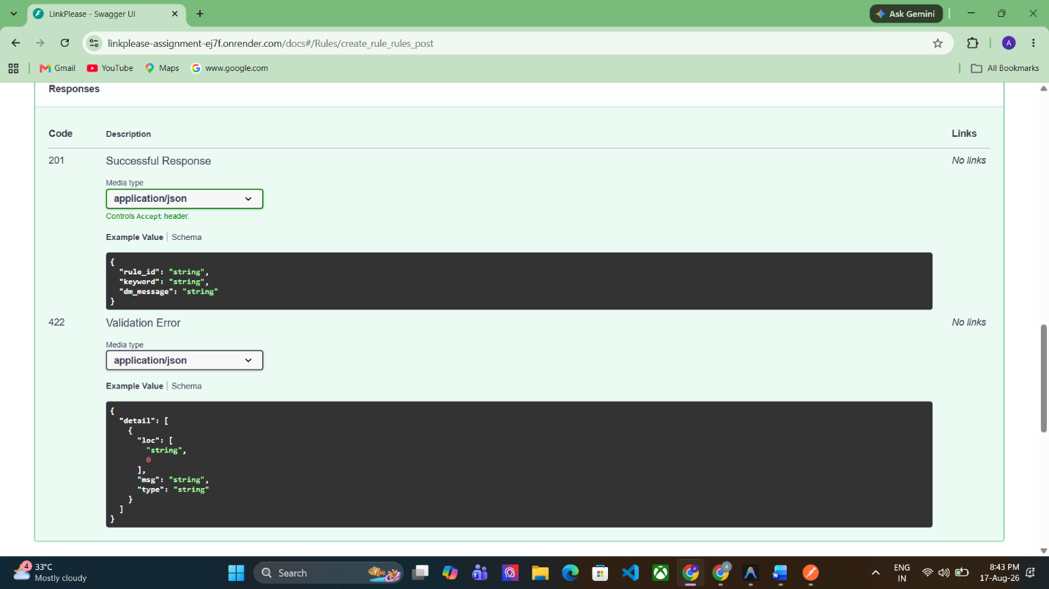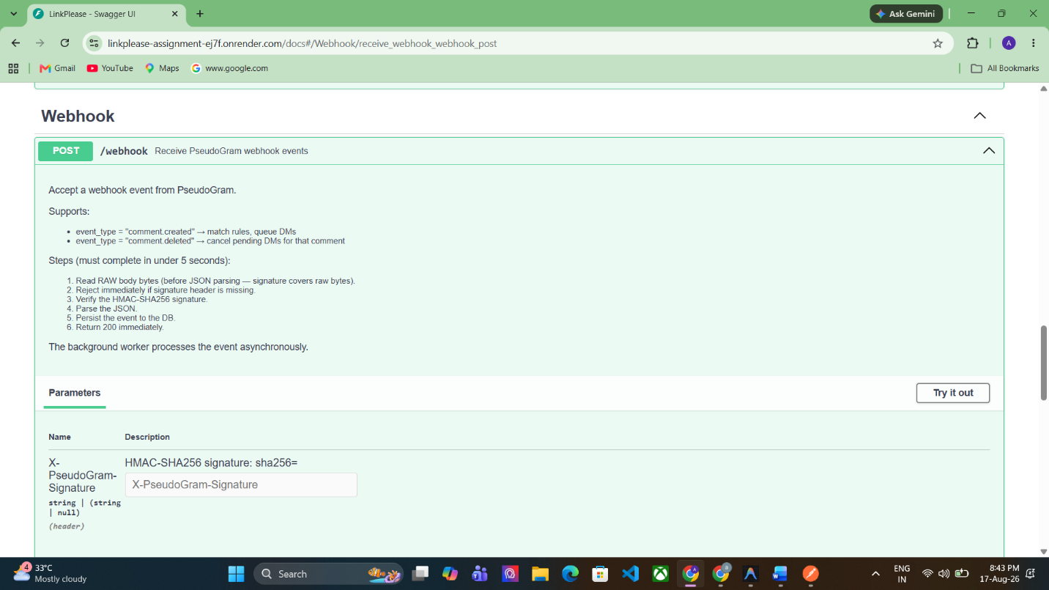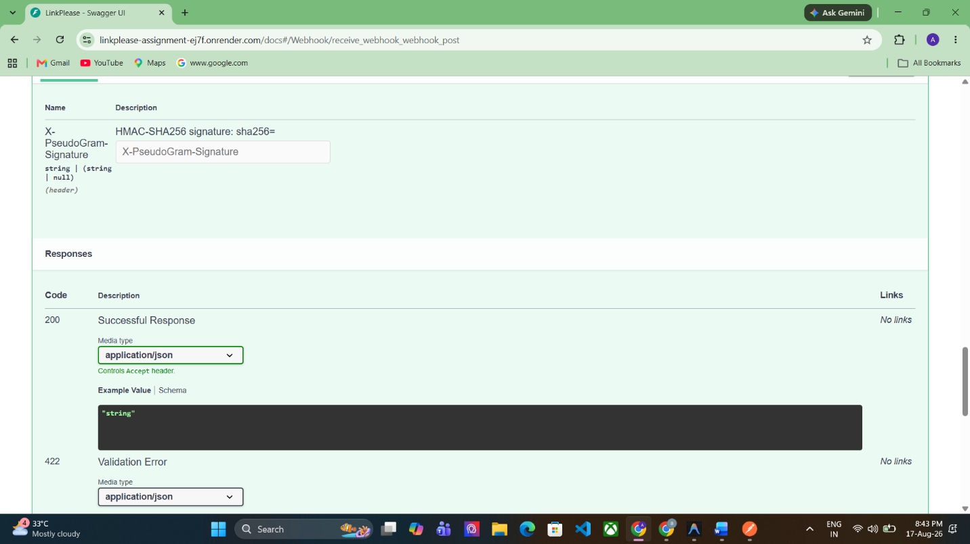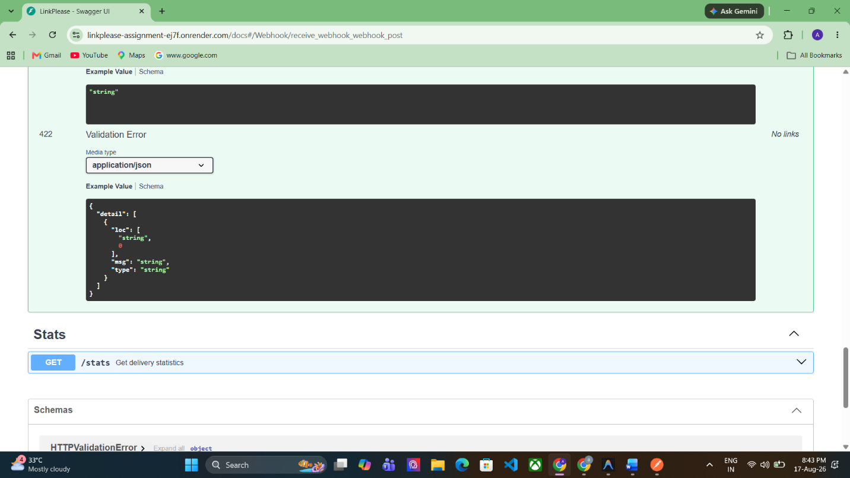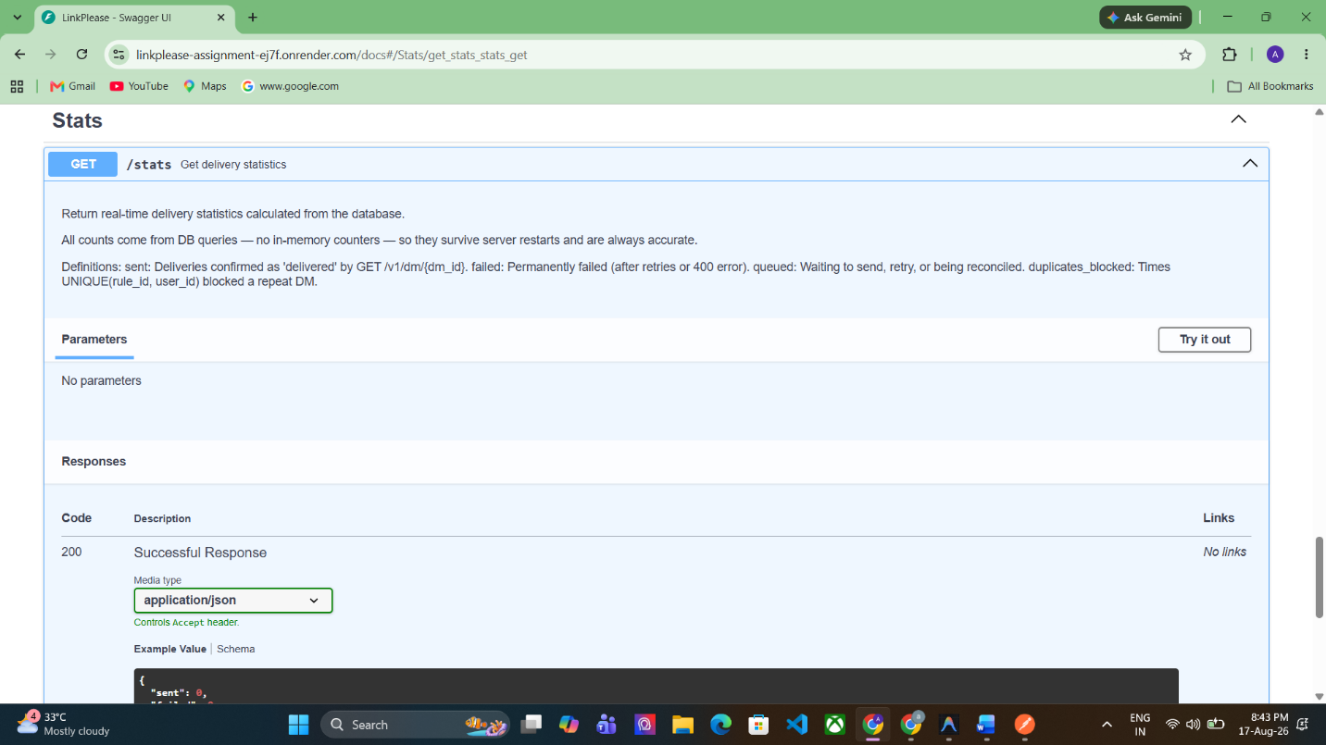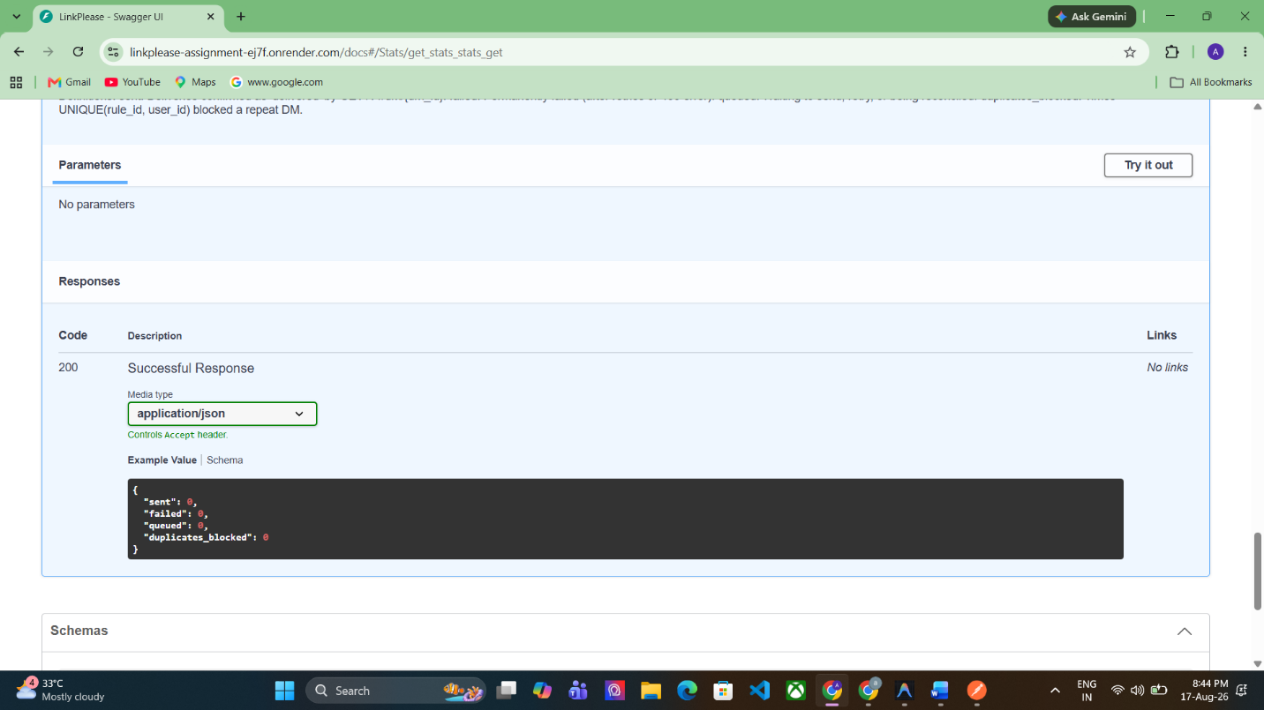
Webhook Security: Incoming webhook requests are verified using HMAC-SHA256 against the raw request body and the API key. Requests with missing or invalid signatures are rejected before processing. Valid events are persisted and processed asynchronously by the background worker.

7. Testing
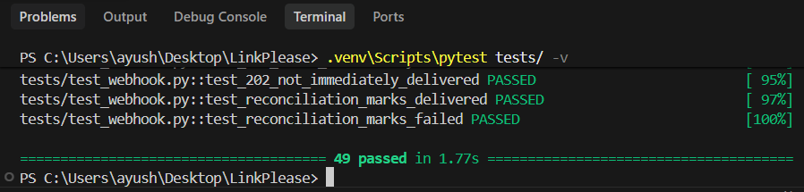

8. Part C — 500-Event Stress Test
